10th April 2013

**YOKOHAMA to Exhibit at Auto Shanghai 2013**

Tokyo – The YOKOHAMA Rubber Co., Ltd., announced today that it will participate in Auto

Shanghai 2013, to be held from April 20 through April 29 (press day: April 20) in Shanghai,

China, through YOKOHAMA Tire Sales (Shanghai) Co. Ltd., its tyre sales company in China. Under the theme “Love Driving, Love Eco,” YOKOHAMA will highlight the joy of driving and high environmental performance – introducing primarily its global flagship tyre brand “ADVAN” and its fuel-efficient tyre brand “BluEarth.”

All lines of “ADVAN” products will be shown, including the latest offering for high-powered premium cars, the “ADVAN Sport V105,” to be released for the first time in China. The “BluEarth” presentation will include the environmental flagship tyre “BluEarth-1” and the “BluEarth AE-01” - the latter won the 2012 Tyre of the Year Award in China. Featuring also its SUV tyre brand “GEOLANDAR,” truck and bus tyres, tyres as original equipment (OE) and more, YOKOHAMA will emphasize the wide range of its total line-up.

There will be a variety of booth events as well. On the 21st, there will be a presentation of the

“ADVAN Sport V105” to the media and a ceremony to mark YOKOHAMA’s being ranked

1st in the “2012 China Original Equipment Tyre Satisfaction Index Study” carried out by the research firm J. D. Power Asia Pacific. On the 27th, popular actor Louis Koo, YOKOHAMA’s celebrity spokesman in China, will visit the booth.

Internationally prestigious auto shows are staged every other year in China, alternating between Beijing and Shanghai. At Auto Shanghai 2011, more than 1,700 companies from 20 countries and regions exhibited their products.

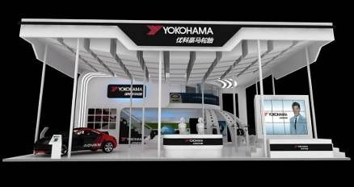

***Image of YOKOHAMA booth***